- COURSE #  Course Title  Semester & Year  Section # CRN # | - 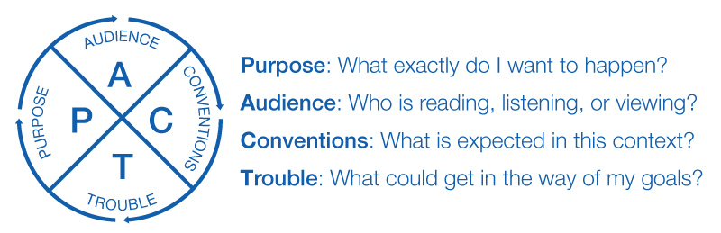 | - Instructor: ____  E-Mail: ___  Phone: ___  Office: ___  Office Hours: ___

Sample Course Overview (emphasizing communication)

This course will introduce you to . . . . .

As part of the Eberly College’s commitment to fostering effective communication skills, this course will also:
- Emphasize informal and formal modes of communication
- Teach discipline-specific communication techniques
- Use a process-based approach with opportunities for feedback and revision
- Base a substantial portion of the final grade on successful spoken and/or written performance

For more information about the SpeakWrite program, please visit http://speakwrite.wvu.edu/

Goals/Outcomes
By the end of the course you should be able to:

- Evaluate how concepts such as PACT (purpose, audience, conventions, and trouble spots) inform communication practices

Required Texts
Author, title, date. ISBN:
Statement of Policies (see WVU Academic Policies and Syllabus Statements)
- Attendance:
- Late work:
- Academic Integrity:
- Emergencies:
- Social justice and inclusivity: .

Course Requirements / Assignment Overview

Feedback on Assignments

Sample Writing Criteria

Effective communication relies on clear prose that attends to purpose and audience as well as conventions and context; clear communication also anticipates questions or potential trouble spots. (PACT is a useful acronym.) When I evaluate your writing, I will always look first at the quality of your ideas, but exceptional writing must also demonstrate quality of expression. My criteria include the following:
- A – Superior: The work is of near professional quality. The document meets or exceeds the goals and purpose of the assignment. The content is mature, thorough, and well suited for the audience. The style is clear and accurate. The information is well organized and designed and uses appropriate conventions (including correct grammar, mechanics, and documentation). No trouble spots get in the way of achieving goals.
- B – Good: The document generally meets its purpose, but would benefit from greater clarity (perhaps by developing one or two points). The writer may need to anticipate audience needs and questions more fully at one or two points. In terms of conventions, the writer may have missed minor (easily correctable) errors in grammar, format, or style.
- C – Competent: The document needs significant improvement in concept, details, development, organization, grammar, or format. It may be formally correct but superficial in content. It stands a chance of meeting its goals in terms of audience, purpose, and conventions, but a few trouble spots remain.
- D – Marginally Acceptable: The document meets some of the objectives but ignores others. Trouble spots are serious--such as under-developed content or so many errors that they start to disrupt meaning. The document requires extensive revision to succeed.
- F – Unacceptable: The document fails to meet basic goals. It does not have enough information, does something other than the assignment required, or it contains excessive errors. A document will also fail if it does not represent the writer’s original work.

Sample Participation Criteria

This course relies on a strong community where everyone participates. Here are my expectations and standards:
- A: You are prepared for every class period and contribute to class discussion every (or almost every) day; this includes bringing the course materials on a daily basis. You have insightful and relevant contributions and clear engagement with the day’s readings/activities. You respond to your peers’ comments and questions, ask questions of your own, and help facilitate dialogue.
- B: You are prepared for every class period and contribute to most class discussions; you usually have the course materials. Comments are relevant and insightful and demonstrate a careful reading of the texts assigned. You respond to other’s comments on a regular basis and take on an active role in class activities.
- C: You are typically prepared for class and contribute to class discussion approximately half of the time; you bring the course materials about half of the time. Sometimes your contributions are off-topic or prevent dialogue from moving forward. During group work, you take on a quiet role.
- D: You rarely comment or add insight to class discussion; you rarely bring the course materials. You do not display your preparedness for class, which is reflected in your lack of contributions and/or low quiz scores. You may show little interest in the material or may be off-task during class (reading non-relevant material, sending texts, sleeping, etc.).
- F: You arrive late to class, are unprepared for class discussion/activities, distract others or disrupt productive work; you often fail to follow the classroom policies and procedures and/or have missed five or more classes.

Resources & Support
- SpeakWrite Consulting Services. For more information about the SpeakWrite program and for information about writing and presentation support offered through the SpeakWrite Studio, call 304.293.5788, visit http://speakwrite.wvu.edu/writing-studio, or stop by G02 Colson Hall (lower level).

Schedule of Work Due
Please Note: On the rare chance that WVU cancels classes, we will typically maintain our schedule via eCampus. Please check your WVU e-mail and eCampus for announcements.

Date | Work Due

