Sample Syllabus Header
COURSE NUMBER – Course Title
Instructor:  E-mail:  Phone: | 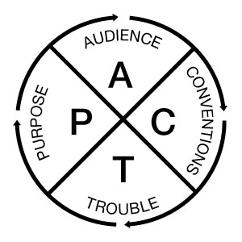 | Office Hours:  Office

Semester/Year. Where and when the course meets.

PACT for Effective Communication: Four key questions shape responses to many situations:
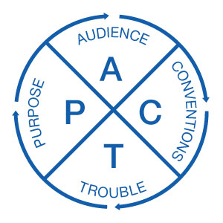 | Purpose: What exactly do I want to happen as a result of this communication?  Audience: Who is reading, listening, or viewing?  Conventions: What is expected in this context?  Trouble spots: What could get in the way of my goals?

Sample Course Goals (only one is needed)
- Evaluate how concepts such as PACT (purpose, audience, conventions, and trouble spots) inform communication practices in our discipline;
- Revise both writing and presentations in response to feedback.
- Foster critical thinking, writing, and communication skills.

Sample Language for Feedback
Written Work. Effective communication relies on clear prose that attends to purpose and audience as well as conventions and context; clear communication also anticipates questions or potential trouble spots. (PACT is a useful acronym.) When I evaluate your writing, I will always look first at the quality of your ideas, but exceptional writing must also demonstrate quality of expression. Please see the specific criteria on each assignment.
- A – Superior: The work is of near professional quality. The document meets or exceeds the goals and purpose of the assignment. The content is mature, thorough, and well suited for the audience. The style is clear and accurate. The information is well organized and designed and uses appropriate conventions (including correct grammar, mechanics, and documentation). No trouble spots get in the way of achieving goals.
- B – Good: The document generally meets its purpose, but would benefit from greater clarity (perhaps by developing one or two points). The writer may need to anticipate audience needs and questions more fully at one or two points. In terms of conventions, the writer may have missed easily correctable errors in grammar, format, or style.
- C – Competent: The document needs significant improvement in concept, details, development, organization, grammar, or format. It may be formally correct but superficial in content. It stands a chance of meeting its goals in terms of audience, purpose, and conventions, but trouble spots remain.
- D – Marginally Acceptable: The document meets some of the objectives but ignores others. Trouble spots are serious--such as under-developed content or so many errors that they start to disrupt meaning. The document requires extensive revision to succeed.
- F – Unacceptable: The document fails to meet basic goals. It does not have enough information, does something other than the assignment required, or it contains excessive errors. A document will also fail if it does not represent the writer’s original work.

Informal Work and Written Exams in Larger Classes. I will provide feedback to the class as a whole to note strengths to maintain and trouble spots to avoid as you continue to improve your abilities to write clearly and convincingly. Knowledge is cumulative. Understanding your strengths and challenges will help you do better on subsequent tasks. You are also welcome to meet during office hours or by appointment to review your answers.

Presentations.
- Excellent (A): The presentation exceeds the goals and the purpose of the assignment. The data and the analysis are relevant to the class and demonstrate that you understand the topic. Your presentation is clear and well organized and it is easy to follow by your audience.
- Very Good (B): The presentation meets the goals and the purpose of the assignment. The data and the analysis are relevant to the class and demonstrate that you understand the topic. Your presentation has some trouble spots but it is still easy to follow by your audience. The style is generally clear and the information is generally well organized.
- Competent (C): The presentation meets the goals and the purpose of the assignment but needs some improvement. The data and the analysis are relevant to the class and demonstrate that you have some command of topic. Your presentation has some trouble spots that may make it difficult to follow by your audience at times. The style is not always clear and the information is sometimes disorganized.
- Pass (D): The presentation partially meets the goals and the purpose of the assignment but needs major improvements. The data and the analysis are somehow relevant to the class and show only partial command of the topic. The structure is disorganized and has some trouble spots that make it difficult to follow by your audience.
- Fail (F): The presentation does not meet the minimum requirements. It does not provide enough data or information and it has frequent trouble spots that make it difficult to follow by your audience.

Participation Criteria. This course relies on spoken participation every class period.
- A: You are prepared for every class period and contribute to class discussion every (or almost every) day; this includes bringing the course materials on a daily basis. You have insightful and relevant contributions and clear engagement with the day’s readings/activities. You respond to your peers’ comments and questions, ask questions of your own, and help facilitate dialogue.
- B: You are prepared for every class period and contribute to most class discussions; you usually have the course materials. Comments are relevant and insightful and demonstrate a careful reading of the texts assigned. You respond to other’s comments on a regular basis and take on an active role in class activities.
- C: You are typically prepared for class and contribute to class discussion approximately half of the time; you bring the course materials about half of the time. Sometimes your contributions are off-topic or prevent dialogue from moving forward. During group work, you take on a quiet role.
- D: You rarely comment or add insight to class discussion; you rarely bring the course materials. You do not display your preparedness for class, which is reflected in your lack of contributions and/or low quiz scores. You may show little interest in the material or may be off-task during class (reading non-relevant material, sending texts, etc.).
- F: You arrive late to class, are unprepared for class discussion or activities, distract others, or disrupt productive work; you often fail to follow the classroom policies and procedures and/or have missed five or more classes.

Sample Syllabus Links to SpeakWrite

SpeakWrite Consulting Services. For more information about the SpeakWrite program and for information about writing and presentation support offered through the SpeakWrite Studio, visit https://speakwrite.wvu.edu/students or stop by G02 Colson Hall.

OR

You may want to explore the resources on the SpeakWrite website.
See especially the link to the Writing Studio: https://speakwrite.wvu.edu/students

